**SR UNIVERSITY**

**AI ASSISTED CODING LAB**

**ASSIGNMENT 8**

**NAME**: MOHAMMED MUTAKABIR HUSAIN

**H.NO**: 2503A51L35

**AssignmentNumber:8.2**

**TASK 1:**

**DESCRIPTION:**

Use AI to generate test cases for a function is_prime(n) and then implement the function.

**Requirements:**

* Only integers > 1 can be prime.
* Check edge cases: 0, 1, 2, negative numbers, and large primes.

**PROMPT:**

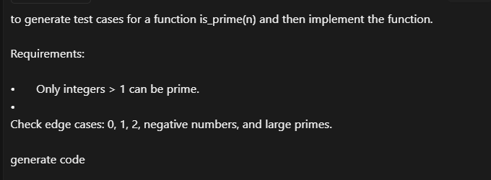

**CODE GENERATED:**

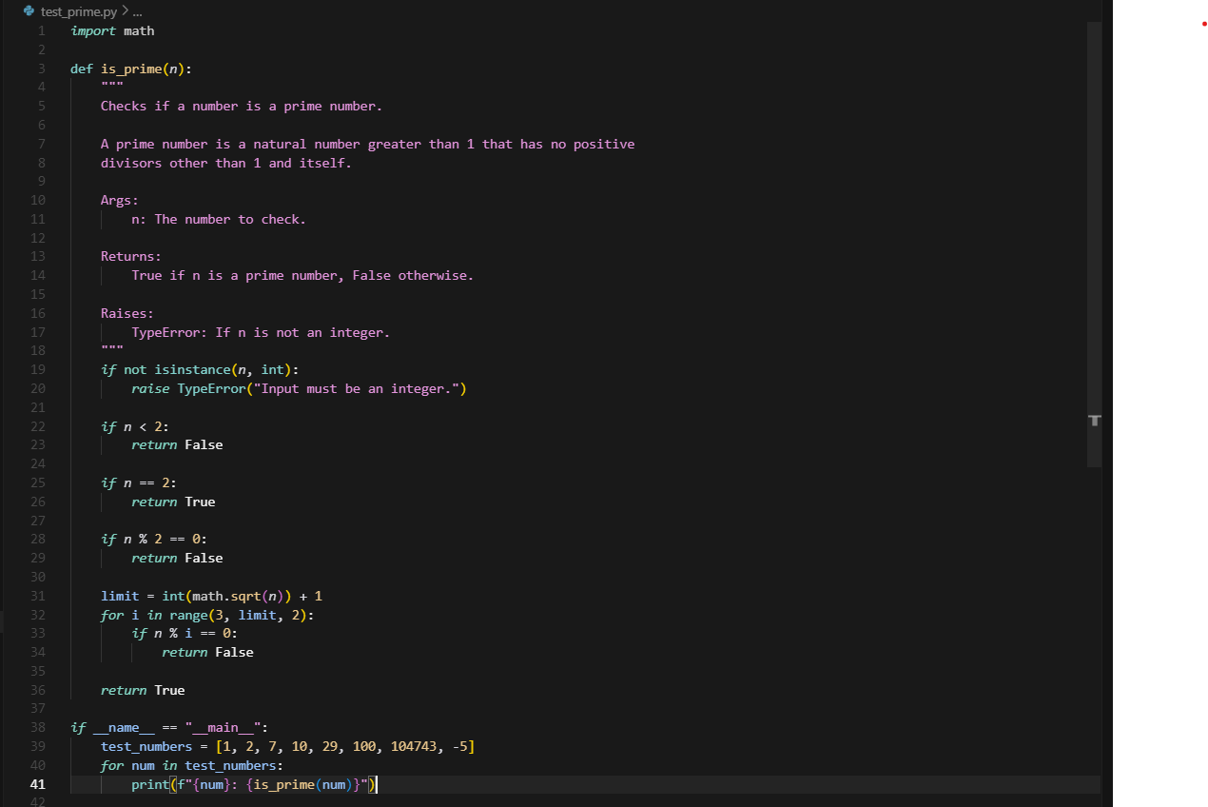

**OUTPUT:**

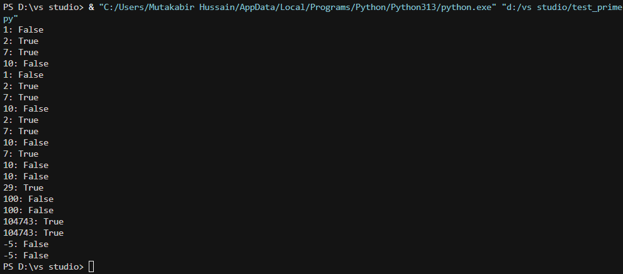

OBSERVATION:

The output displays the results of a Python script which was given by ai in the visual studio

**TASK 2**

**Task Description#2 (Loops)**

* Ask AI to generate test cases for celsius_to_fahrenheit(c) and fahrenheit_to_celsius(f)

**Requirements**

* Validate known pairs: 0°C = 32°F, 100°C = 212°F.
* Include decimals and invalid inputs like strings or None

**Prompt:**

**

**

**Observation:**

I observed that the final output matched the expected result dual conversion functions with complete tests and safe type handling.

**TASK 3**

**Task Description#3**

Use AI to write test cases for a function count_words(text) that returns the number of words in a sentence.

**Requirement**

Handle normal text, multiple spaces, punctuation, and empty strings.

**Expected Output#3**

Accurate word count with robust test case validation.

**Prompt:**

**Observation:**

Handles normal text → "Hello world" → 2

Handles multiple spaces → "Hello world" → 2

Handles punctuation → "Hello, world!" → 2 (punctuation counted as part of word, still 2 words)

Handles empty string → "" → 0

**TASK 4**

**Task Description#4**

* Generate test cases for a BankAccount class with:

**Methods:**

deposit(amount)

withdraw(amount)

check_balance()

**Requirements:**

* Negative deposits/withdrawals should raise an error.
* Cannot withdraw more than balance.

**Expected Output#4**

* AI-generated test suite with a robust class that handles all test cases.

**Prompt:**

**Observation:**

AI has generated all test cases and have executed all of them with methods

deposit(amount)

withdraw(amount)

check_balance()

**TASK 5**

**Task Description#5**

Generate test cases for is_number_palindrome(num), which checks if an integer reads the same backward.

**Examples:**

121 → True

123 → False

0, negative numbers → handled gracefully

**Expected Output#5**

* Number-based palindrome checker function validated against test cases.

Prompt:

Observation:

When running the tests, all cases passed successfully